Sustainability for Future Opportunities: A Profile of David Hartke
David Hartke is a fourth generation soybean farmer in Teutopolis, a small Illinois town in the heart of America. The Hartkes’ family farm was established by his German immigrant ancestors in 1902. David and his father Phillip run what is known today as the Hartke Swine Center, Inc., growing soybeans, corn and wheat, as well as raising hogs and cattle, to help feed a growing world. The farm raises sustainable products for their customers as well as future generations of the family.
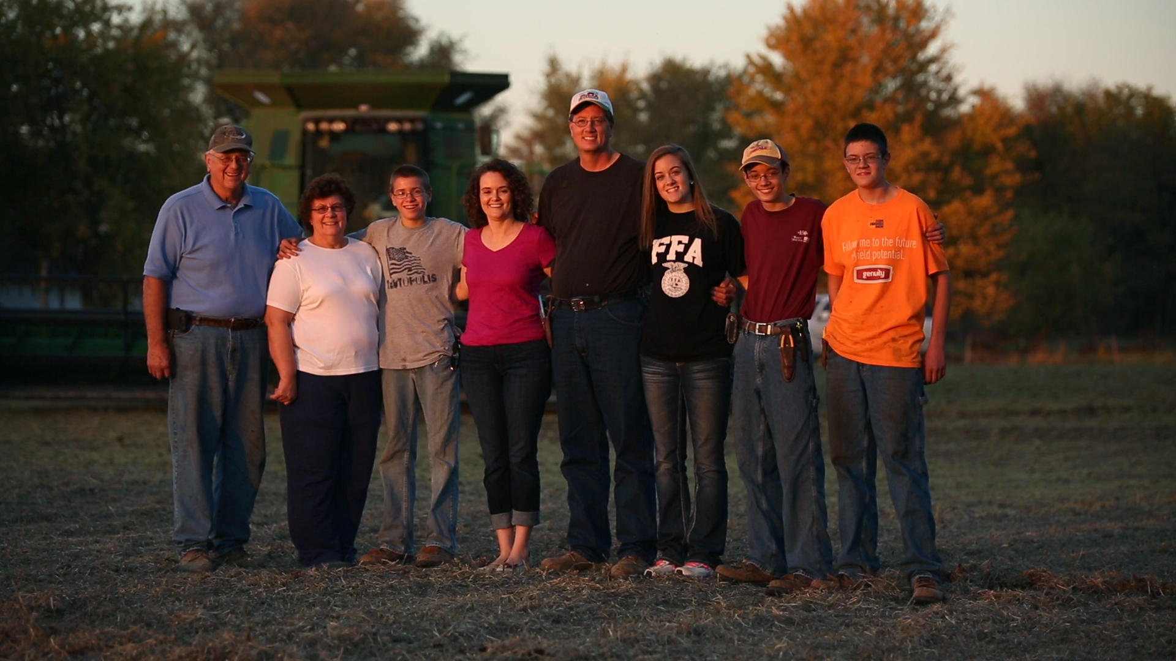
“For me, farming is not just a career or a family tradition,” says David. “It’s a way of life that I hope my children, Alex, Dustin, Garrett and Taylor, will also enjoy if any of them follow me into farming.”
“I care for the land and the environment in which we live. I want to provide the customers of my soybean crop with the same high-quality standards that I use to feed my hogs,” David continues. “I grow sustainable products so that my kids have the opportunity to work on this farm that my family began more than 100 years ago.”
“Every day when we make decisions, we think about the future. Where do we want to be, what impact will this decision have on the land over the next 10 or 20 years? And most of all, how can we ensure that I pass the farm on to the next generation in as good, or better, condition than it was passed down to me?”

